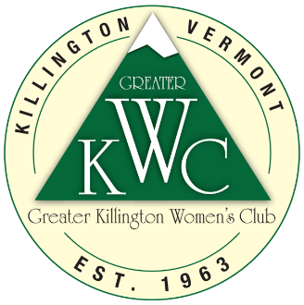

***Greater Killington Women’s Club***

**BUSINESS MEMBERSHIP FORM**

GKWC invites local women-owned & co-owned businesses to consider joining the club in our new Business Membership category. This level of membership also includes a new promotional opportunity where your business logo *(& link back to your website)* will be featured on the homepage of our new website. In addition, your business will be a preferred partner for future club events and activities. You will also be recognized in our monthly e-newsletter and on our social media channels. The cost is only $200 per year. Thank you for your support!

**Business Name:** _______________________________________________________________

**Business Address:** _____________________________________________________________

**Business Website:** _____________________________________________________________

**Main Contact Name:** ___________________________________________________________

**Contact Phone:** ________________________________________________________________

**Contact E-mail:** ________________________________________________________________

Please e-mail your business artwork to **gkwcvt@gmail.com**. Please also send this completed sponsorship form via email to gkwcvt@gmail.com or mail to GKWC – Business Member, P.O. Box #68, Killington VT 05751. Please include your $200 payment via mail with your application or send your payment via **PayPal** using this QR code below and indicate it is for a business membership:



*Greater Killington Women’s Club, P.O. Box #68, Killington VT 05751*